- 总则General Policy
为了确保计算机系统的安全性，要求接入网络的计算机系统在生命周期须：
- 定期更新补丁；
- 安装杀毒软件并定期更新反病毒库；
- 执行系统加固并定期检查；
- 定期漏洞扫描；
- 配置时间同步；
- 配置BIOS密码并定期检查；
- 设置BIOS启动盘顺序；
- 对关键业务系统做定时备份；
- 当计算机系统的生命周期结束或者其存储介质报废时，须进行彻底销毁以确保数据不能被恢复。
To ensure the security of computer systems, network-connected computer systems must meet the following requirements throughout their lifecycle:
- Regularly update and install patches;
- Install antivirus software and update virus definitions periodically;
- Perform system hardening and regular inspections;
- Conduct periodic vulnerability scanning;
- Configure time synchronization;
- Set BIOS passwords and inspect them regularly.
- Set the BIOS boot order.
- For critical business systems, scheduled backups must additionally be implemented.
- At the end of a computer system's lifecycle or when its storage media is decommissioned, the device or medium must be thoroughly destroyed to guarantee that data cannot be recovered.
- 适用范围Scope
本流程适用于公司所有计算机系统的管理，包括但不限于服务器、终端设备、网络设备、存储设备及其他系统组件。
This process is applicable to the management of all computer systems in the company, including but not limited to servers, terminal devices, network devices, storage devices, and other system components.
- 控制流程Control Processes
设备系统进入高安全区前，应对系统进行全盘病毒查杀，确认无病毒威胁后，按下图系统安全控制流程接入
Before the equipment system enters the HSA, conduct a full-system virus scan. After confirming there are no virus threats, connect the system following the system security control process shown in the figure below.

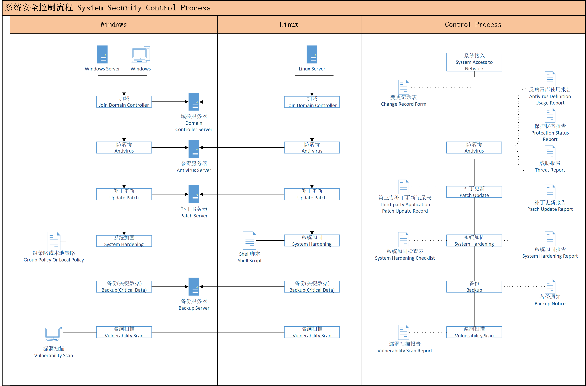
- 补丁更新Patch Update
根据公司业务需求，使用到了Windows、Redhat以及其他一些第三方应用。针对以上这些系统，分别制定了补丁管理流程。
Based on the company’s business requirements, Windows, Red Hat, and other third-party applications are in use. Separate patch management processes have been established for each of these systems.
  - Windows和Linux补丁更新 Windows and Linux Patch Updates
Windows系统和Linux系统采用Patch Manager服务器进行补丁更新，在IT Infrastructure网络部署Patch Manager服务器，配置要求如下：
Windows and Linux systems use Patch Manager servers for patch updates, and Patch Manager servers are deployed on IT Infrastructure networks with the following configuration requirements:
- Patch Manager设置为定时每天从官网同步补丁；
Patch Manager is set to synchronize patches from the official website on a scheduled daily basis.
- Patch Manager更新的补丁设置为安全更新；
Patch Manager updates patches set as security updates.
- Patch Manager设置为自动审批规则，允许上述补丁自动审批；
Patch Manager is set to automatic approval rules, which allows the above patches to be automatically approved.
- 已经加域的设备通过域控策略自动安装Patch Manager代理，没有加域的设备手动安装Patch Manager代理；
Devices that have already been added to the domain automatically install the Patch Manager agent through domain control policies, while devices that have not been added to the domain manually install the Patch Manager agent.
- Patch Manager设置为每周发送系统合规性报表和需要重启的系统报告到IT管理员邮箱。
Patch Manager is set to send weekly system compliance reports and system restart reports to the IT administrator's email.

确保补丁被有效更新的流程如下：
Process to Ensure Effective Patch Updates:

1).在新的终端接入网络前，IT团队须先使用外网将其更新到最新;
Before the new terminal is connected to the network, the IT team must first use the external network to update it to the latest version.
2).IT管理员须根据《IT资产清单》确保所有的系统都接入了Patch Manager；
IT administrators must ensure that all systems are connected to Patch Manager according to the “IT Asset List”.
3).IT管理员须每周从邮件查看Patch Manager 报告。当更新异常或需要重启时，IT管理员须在当月内调查处理，确保当月补丁都被正确的更新。当补丁更新异常且会对业务产生影响时，需填写《补丁异常处理表》，由IT部门与业务部门评估后，由IT部门出具处理方案，由IT经理和CISO签字同意后执行。
IT administrators are required to review Patch Manager reports via email on a weekly basis.
When there is an abnormal update or a restart is required, the IT administrator must investigate and handle it within the current month to ensure that all patches are updated correctly.When the patch update is abnormal and will have an impact on the business, the "Patch Exception Handling Form" needs to be filled out. After evaluation by the IT department and the business department, the IT department will issue a handling plan, which will be signed and approved by the IT manager and CISO before execution
4).当操作系统版本迭代导致在用系统版本即将停止更新时，IT管理员要提前做好评估并做好升级计划。如需升级硬件才能适用新版本，则提交申购申请和升级计划给管理层审批，并按照计划逐步实施。
When the iteration of the operating system version causes the current system version to stop updating, IT administrators should make an assessment in advance and prepare an upgrade plan. If hardware upgrade is required to adapt to the new version, submit a subscription application and upgrade plan to the management for approval, and gradually implement according to the plan.
  - 第三方应用补丁更新Third-Party Applications Patch Update
针对第三方应用制定《核准软件名录》与《第三方软件与资产对应表》，仅允许该名录内的软件在公司范围内时被使用。第三方应用采用人工做补丁更新，具体的流程如下：
Establish “Approved Software Catalog” and “Third Party Software And Asset Correspondence Table” for third-party applications, allowing only software listed in this catalog to be used company-wide. Manual patch update processes will be implemented for third-party applications, with detailed steps outlined below:
1).每季度做一次第三方应用补丁更新；
Update third-party application patches quarterly;
2).IT管理员根据《核准软件名录》中的软件从官方查看新版本是否有修补漏洞，若存在则制定计划更新，并将更新结果填写到《第三方补丁更新记录表》。
The IT administrator checks whether the new version of the software in the "Approved Software Catalog" has patched vulnerabilities from the official website. If there are, they develop a plan to update and fill in the update results in the "Third-party Application Patch Update Record".
- 病毒控制 Virus Control
  - 病毒控制规定 Virus Control Regulations
安全网络内的所有计算机系统须有效防范病毒，为此采用卡巴斯基企业版作为病毒防御的系统，在IT Infrastructure网络部署卡巴斯基管理服务器，其配置要求如下：
All computer systems within the secure network must be effectively protected against viruses. Therefore, Kaspersky Enterprise Edition is used as the system for virus defense, with the following configuration requirements:
1).管理服务器配置定时“将更新下载至管理服务器存储库”任务，用于每天从官方同步反病毒库和自身补丁到管理服务器；
The task of "downloading updates to the management server repository" is scheduled for the management server configuration, which is used to synchronize the official antivirus database and self patches to the management server every day;
2).管理服务器配置触发“更新”任务，触发条件为“当新更新下载至存储库时”，用于客户端从管理服务器更新反病毒库和自身补丁；
Configure the 'update' task on the management server, with the trigger condition being 'when a new update is downloaded to the repository', for the client to update the antivirus library and its own patch from the management server;
3).管理服务器配置定时“恶意软件扫描”任务，用于每天对终端进行全盘扫描；
Configure a scheduled 'malware scanning' task on the management server to perform daily comprehensive scanning of terminals;
4).管理服务器配置定时“备份管理服务器数据”任务，用于对服务器数据进行备份；
Configure a scheduled 'Backup Management Server Data' task on the management server to backup server data;
5).管理服务器配置定时“传送报告”任务，用于向IT团队邮件发送“保护状态报告”和“反病毒库使用报告”，便于IT团队了解终端的状态；
Configure a scheduled 'report delivery' task on the management server to send 'protection status report' and 'antivirus library usage report' via email to the IT team, facilitating their understanding of the terminal's status;
6).管理服务器配置触发“传送报告”任务，用于当发现病毒时向IT团队邮件发送“威胁报告”，便于IT团队及时对病毒进行处理。
Configure and trigger the 'Send Report' task on the management server to send a 'Threat Report' to the IT team via email when a virus is detected, facilitating timely virus handling by the IT team.
7).在DMZ区的服务器使用卡巴斯基官方更新源进行反病毒数据库的更新。
Servers in the DMZ use the official Kaspersky update source for anti-virus database updates.
  - 病毒控制流程 Virus Control Process
为确保病毒被有效防御，具体的控制流程如下：
To ensure effective defense against the virus, the specific control process is as follows:
1).IT团队须根据《IT资产清单》确保所有的Windows和Linux系统都安装了卡巴斯基客户端。
IT teams must ensure all Windows and Linux systems listed in the "IT Asset Inventory" have the Kaspersky Endpoint Security client installed.
2).在新的终端接入网络前，IT团队须先用最新反病毒库的杀毒软件进行全盘杀毒，确定没有发现病毒后方可接入网络。
Before allowing new endpoints to connect to the network, IT teams must:Perform a full system scan using antivirus software with the latest virus definitions.Confirm no threats are detected before granting network access.
3).IT团队须每天从邮件查看“保护状态报告”和“反病毒库使用报告”。确保所有终端都被正确保护且反病毒库更新到最新。
IT teams must check the "Protection Status Report" and "Anti Virus Database Usage Report" via email every day. Ensure that all terminals are properly protected and the antivirus database is updated to the latest version.
4).IT管理员须每天从邮件查看是否收到“威胁报告”。如发现病毒，处理过程如下：
IT administrators must check daily emails for “Threat Report”. If a virus is detected, follow these steps:
A.须立即优先调查病毒是否扩散？如存在扩散现象，须对发现病毒的终端立即断网，以免进一步扩散到其他终端，并按安全事件进行通报。
Immediately prioritize investigating whether the virus has spread.If spreading is confirmed:
-Disconnect the infected endpoint from the network to prevent further propagation.
-Escalate the incident as a security event.
B.接下来对发现病毒的终端进行调查，分析病毒的源头、影响程度，掐断病毒的源头并对终端进行离线查杀。
Investigate the infected endpoint to:
-Analyze the source of the virus and scope of impact.
-Eliminate the infection source and perform an offline virus scan and removal.
- 确定终端病毒已清除后，再将终端接入网络。全过程填写《安全整改记录表》。
Only reconnect the endpoint to the network after confirming complete virus eradication.Document the entire process in the “Security Correction Record Form”.
- 时间同步Time synchronization
以IT基础架构网络的域控服务器作为时间同步服务器，确保网络内所有计算机系统的时间得以同步。
Using the domain control server of the IT infrastructure network as a time synchronization server to ensure that the time of all computer systems in the network is synchronized.
1).加域的Windows通过域控策略设置NTP时间同步；
Windows with added domains set NTP time synchronization through domain control policies;
- .未加域的Windows设置时间服务器为域控服务器；
Set the time server as a domain control server for Windows without adding a domain;
- .Linux服务器设置通过域控服务器同步时间。
Configure the Linux server to synchronize time with the domain controller.
- 系统加固 System Hardening
为了降低安全网络内系统的风险，须通对所有系统实施系统加固，具体的流程如下：
In order to reduce the risk of systems within the secure network, it is necessary to implement system Hardening for all systems. The specific process is as follows:
1).IT团队每年根据CIS Benchmark制定并更新内部的系统加固标准(参见附件2和附件3)；
IT teams annually develop and update internal system hardening standards based on CIS Benchmarks (refer to Attachment 1 and Attachment 2).
2).IT团队须根据《IT资产清单》确保所有的Windows和Linux系统都实施了加固；
IT teams must ensure all Windows and Linux systems listed in the "IT Asset Inventory" are hardened according to the standards.
3).在新的终端接入网络时，要实施系统加固；
System hardening must be applied to new endpoints before granting network access.
4).每季度对系统加固进行检查，并记录检查结果到《系统加固检查表》。
Inspect the system reinforcement every quarter and record the inspection results in the 'System Hardening Checklist'.
5).如检查中发现没有被加固的条目，须记录到《安全整改记录表》并在一周内完成整改。
If any items that have not been reinforced are found during the inspection, they must be recorded in the "Safety Rectification Record Form" and rectified within one week.
- 漏洞扫描Vulnerability Scanning
须对安全网络内的所有系统定期做漏洞扫描(参考《网络安全控制流程》第3.2章节)，并对发现的漏洞根据流程进行处理。
Regular vulnerability scans must be conducted on all systems within the secure network (refer to Chapter 3.2 of the Network Security Control Process), and any discovered vulnerabilities must be addressed according to the process.
- 备份管理Backup Management
对于影响核心业务的系统或数据须做好备份，具体流程如下：
For systems or data that affect core business, backup must be done, and the specific process is as follows:
1).由业务部门对需要备份的系统或数据提出备份需求；
The business department proposes backup requirements for the systems or data that need to be backed up;
2).由IT团队根据备份需求制定备份技术方案；
The IT team will develop a backup technology solution based on backup requirements;
3).由IT团队根据备份方案实施备份，并进行首次恢复来测试备份的可用性；
The IT team implements backup according to the backup plan and performs the first recovery to test the availability of the backup;
4).后续须每年对备份进行一次恢复测试；
Subsequently, an annual recovery test must be conducted on the backup;
5).当出现意外导致系统或数据故障时，启用备份进行恢复以保障业务持续性；
When unexpected system or data failures occur, enable backup for recovery to ensure business continuity;
6).以上过程须记录在《备份和恢复记录表》中。
The above process must be recorded in the 'Backup and Recovery Record Form'.
- 变更管理Change Management
变更管理流程参见《网络安全控制流程》第3.1章节，系统变更的范围包括：系统接入、系统组件变更、系统撤销。
The change management process can be found in Chapter 3.1 of the Network Security Control Process. The scope of system changes includes System Deployment, system component changes, and system revocation.
- 资产撤销管理和存储介质管理Asset Revocation Management And Storage Medium Management
存储过敏感数据的资产和存储介质，与存储过的敏感信息的密级同级，因此需要妥善管理这些资产和存储介质。具体的管理规定和流程如下：
Assets and storage media that have stored sensitive data have the same level of confidentiality as stored sensitive information, so it is necessary to manage these assets and storage media properly. The specific management regulations and procedures are as follows:
1).高安全区安全网络中的所有系统(包括网络设备)禁止使用移动存储，包括U盘、移动硬盘、光盘等。
All systems (including network devices) in the high security zone's secure network are prohibited from using removable storage, including USB drives, hard drives, CDs, etc.
2).高安全区安全网络中的任何系统或系统上存储介质在撤销时，须填写《变更记录表》，且存储介质须移交给IT团队，并在《存储介质登记与销毁记录表》中登记。
When any system or storage medium on a system in a high security zone secure network is revoked, a "Change Record Form" must be filled out, and the storage medium must be handed over to the IT team and registered in the "Storage Medium Registration and Destruction Record Form".
3).IT团队每半年对撤销的存储介质按照“附件1：存储介质销毁方案”进行销毁。
The IT team destroys revoked storage media every six months according to the "Attachment 1: Storage Media Destruction Plan".
- 相关文件Related Documents
《网络安全控制流程》Network Security Control Process
- 相关记录Related Forms
《IT资产清单》IT Asset Inventory
《核准软件目录》Authorized Software Catalog
《第三方补丁更新记录表》Third-party Application Patch Update Record
《系统加固检查表》System Hardening Checklist
《备份和恢复记录表》Backup and Recovery Record Form
《安全整改记录表》Security Correction Record Form
《变更记录表》Change Record Form
《存储介质登记与销毁记录表》Storage Media Registration and Destruction Record Form
《第三方软件与资产对应表》Third Party Software And Asset Correspondence Table
《补丁异常处理表》Patch Exception Handling Form

附件1 Attachment 1：
存储介质销毁方案
Destruction Scheme for storage media
1.销毁方式Destruction Method
存储介质在销毁之前进行低格格式化后，再根据章节2将存储介质进行物理销毁，使存储介质彻底无法恢复使用。
Before destroying the storage medium, it shall be low-level formatted, and then physically destroyed in accordance with Chapter 2, so that the storage medium is completely unrecoverable and cannot be used anymore.
对于存储介质无法正常低格格式化的情况，直接根据章节2进行物理销毁。
For the case where the storage medium cannot be normally low-level formatted, directly carry out physical destruction in accordance with Chapter 2.
- 销毁过程 Destruction Process
1).存放地点Location
待销毁的存储介质将会存放在机房的存储柜中进行集中的暂时性保存，待审批流程完成后再从存储柜中提取出来做销毁处理，此过程必须在高安全区域内部。
The storage media to be destroyed will be stored in the storage cabinets in the server room for centralized temporary preservation. After the approval process is completed, the storage media will be extracted from the storage cabinets for destruction, and this process must be done in a high-security area.

2).存储介质拆解Storage Media Disassembly
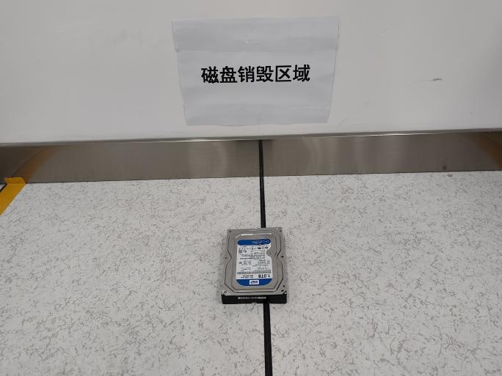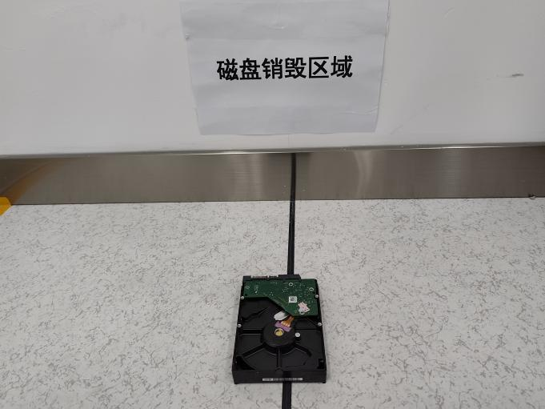
3).取出存储介质组件Remove the storage media assembly

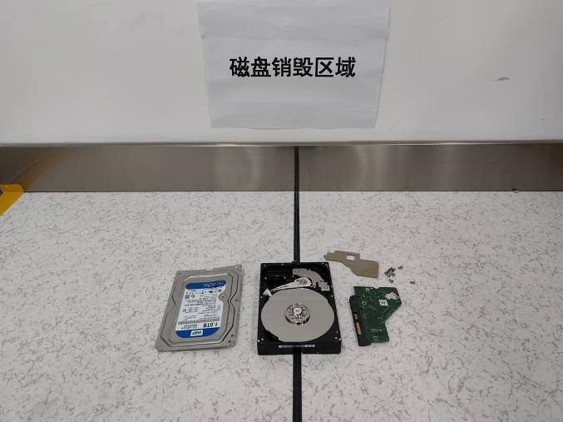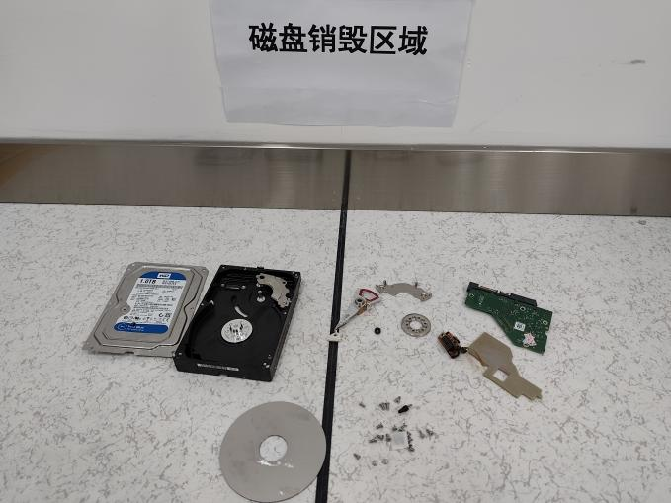

4).销毁存储介质（必须正反面进行划痕，最少三道明显划痕）
Destroy the storage media (must be scratched on both sides, at least three obvious scratches.)

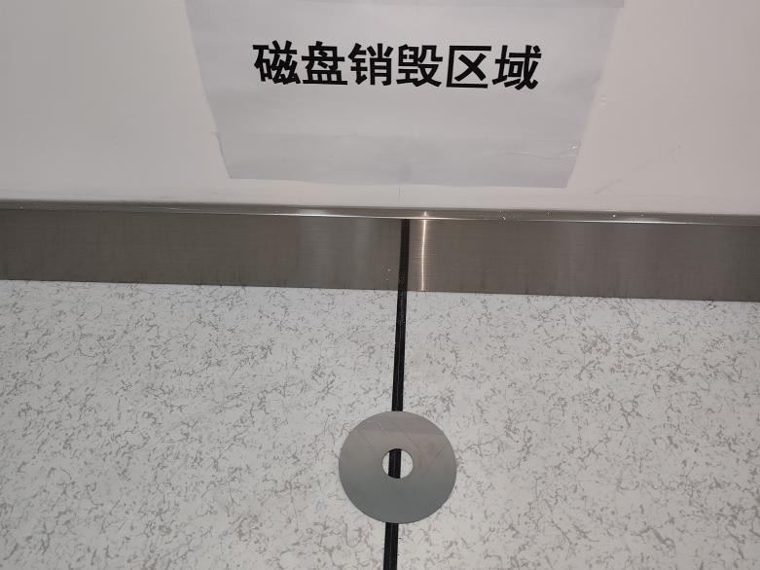
5).第二道工序物理销毁方式：用铁锤将磁盘砸至对折表面凹凸不平
Physical destruction in the second process: the disks are smashed with a hammer until the folded surface is uneven.
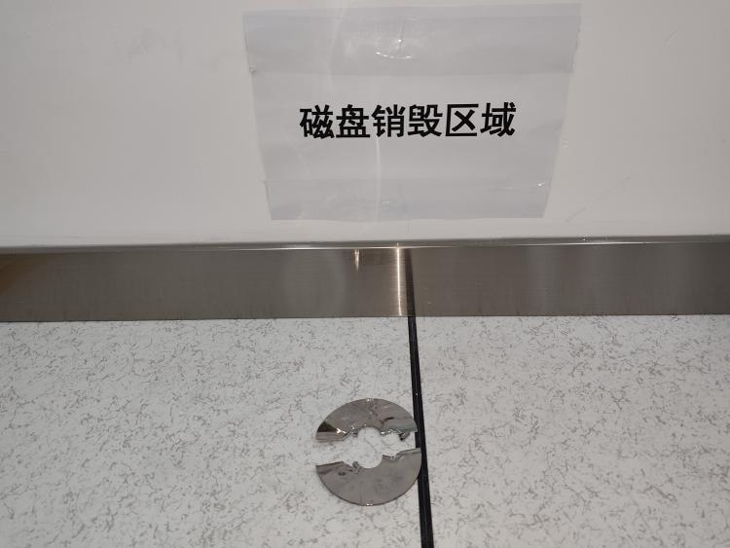

6).处理存储介质控制单元，同样要在控制单元集成板正面划痕，并且用铁锤等重击击碎。
When destroy the storage media, it is need to be scratched the front of the control integrated board and break it with a hammer.
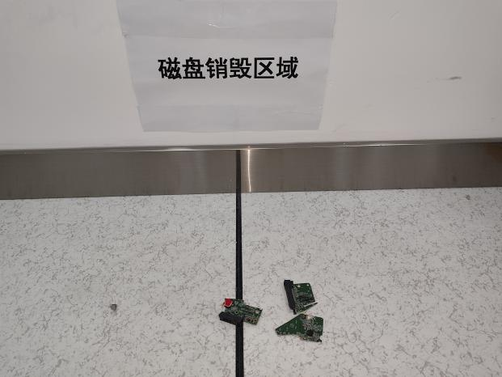
针对固态硬盘（SSD）销毁方式
SSD Destruction Method
- 拆卸硬盘外壳：使用适当工具拆卸硬盘外壳，暴露出内部电路板。
Disassemble the SSD: Use appropriate tools to remove the SSD casing and expose the internal circuit board.
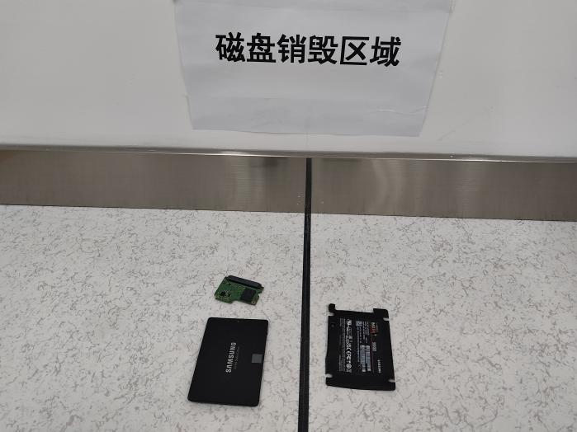
  - 硬盘破坏：通过物理破坏硬盘的存储芯片和电路板，使用大力钳将硬盘切割成多个小块。
hard disk destruction: by physically destroying the hard disk's storage chips and circuit boards, using strong pliers to cut the hard disk into multiple small pieces.
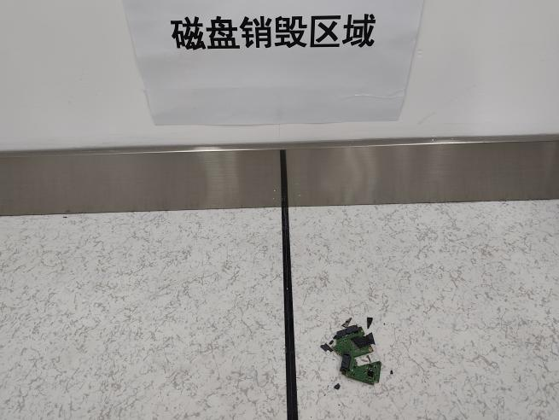
- 确认销毁结果：确保固态硬盘的存储芯片和电路板完全损坏，无法恢复。
Verify Destruction: Ensure that the SSD’s storage chips and circuit board are fully damaged and cannot be restored.

7).登记销毁存储介质信息，含序列号/空间大小/接口/原存储设备/处理人/确认人。
Register the destroyed storage media information, including serial number/space size/interface/original storage device/processor/confirmer

8).销毁记录Destruction of records
销毁的硬件存储介质需要进行填写《存储介质销毁记录表》
The hardware storage medium to be destroyed shall be filled in the storage medium destruction record form.
9).销毁确认Destruction of confirmation
确认人检查存储介质是否与申请内容是否一致，销毁过程是否符合销毁的标准，登记记录是否完整。
The confirmatory person shall check whether the storage medium is consistent with the application content, whether the destruction process meets the destruction standards, and whether the registration record is complete.

附件2 Attachment 2：
Windows系统加固标准
Windows System Hardening Standard
引用 Quote：
CIS_Microsoft_Windows_11_Enterprise_Benchmark_v4.0.0
CIS_Microsoft_Windows_Server_2022_Benchmark_v4.0.0

账户管理政策 Account Management Policy

密码政策 Password Policy
详情参考《系统访问控制流程》第3.3章。
For details, refer to Chapter 3.3 of "System Access Control Process".

1.2 账号锁定策略 Account lockout policy

账号锁定持续时间 Account lock duration
设定账号锁定时间位0分钟，如果攻击者滥用帐户锁定阈值并反复尝试使用特定帐户登录，则可以创建拒绝服务(DoS)条件。一旦配置了帐户锁定阈值设置，帐户将在指定的失败尝试次数之后被锁定。如果将帐户锁定持续时间设置为0，则该帐户将保持锁定状态，直到管理员手动解锁为止。
Setting the account lockout duration to 0 minutes can create a denial of service (DoS) condition if an attacker abuses the account lockout threshold and repeatedly attempts to log in using a specific account. Once the account lockout threshold settings are configured, the account will be locked after the specified number of failed attempts. If the account lockout duration is set to 0, the account will remain locked until the administrator manually unlocks it.

账号锁定阈值 Account lock threshold
设定值位5次，设置帐户锁定阈值可以降低在线密码暴力攻击成功的可能性。设置帐户锁定阈值太低会增加意外锁定和/或恶意参与者故意锁定帐的风险。

Setting the account lockout threshold to 5 times can reduce the likelihood of a successful online password brute force attack. Setting the account lockout threshold too low increases the risk of accidental lockouts and/or intentional lockouts by malicious actors.

本地策略 local policy

2.2安全选项 Security options

账户：来宾账户状态（默认）Account: Guest account status (default)
设置为“禁用” 默认的客户帐户允许未经身份验证的网络用户在没有密码的情况下以客户身份登录。这些未经授权的用户可以访问通过网络访问客户帐户的任何资源。这种功能意味着，任何具有访问客户帐户、来宾组或Everyone组权限的共享网络都可以通过网络访问，这可能导致数据暴露或损坏。

Set to Disabled The default guest account allows unauthenticated network users to log on as the guest account without a password. These unauthorized users can access any resource that has access to the guest account over the network. This capability means that any network share with permissions to access the guest account, the Guests group, or the Everyone group can be accessed over the network, potentially resulting in data exposure or corruption.

账户：使用空密码的本地账户只允许进行控制台登陆（默认） Account: Local accounts with empty passwords are only allowed to log in to the console (default)
设置为“启用” 空白密码是对计算机安全的严重威胁，应通过组织政策和适当的技术措施予以禁止。实际上，Active Directory域的默认设置需要至少包含7个字符的复杂密码。但是，如果能够创建新帐户的用户绕过基于域的密码策略，他们可以使用空白密码创建帐户。例如，用户可以构建一台独立的计算机，使用空白密码创建一个或多个帐户，然后将计算机连接到域。使用空白密码的本地帐户仍然有效。任何知道这些不受保护帐户名称的人都可以使用它来登录。

Set to Enabled Blank passwords are a serious threat to computer security and should be prohibited by organizational policy and appropriate technical measures. In fact, the default setting for Active Directory domains requires complex passwords of at least 7 characters. However, if a user who is able to create new accounts bypasses the domain-based password policy, they can create accounts with blank passwords. For example, a user could build a stand-alone computer, create one or more accounts with blank passwords, and then connect the computer to the domain. Local accounts with blank passwords remain valid. Anyone who knows the name of these unprotected accounts can use it to log on.

审核：如果无法记录安全审核则立即关闭系统（默认） Audit: Shut down the system immediately if unable to log security audits (default)
设置为“禁用” 如果计算机无法将事件记录到安全日志中，则在发生安全事件后可能无法获得关键证据或重要故障排除信息。此外，攻击者可能会产生大量安全日志事件，故意迫使计算机关闭。

Set to Disable If the computer cannot log events to the Security log, critical evidence or important troubleshooting information might not be available after a security incident. Additionally, an attacker could generate a large number of Security log events to intentionally force a computer to shut down.

域成员：对安全通道数据进行数字加密（如果可能）（默认）Domain members: Digitally encrypt secure channel data when possible (default)
设置为“启用” 当计算机加入域时，将创建一个计算机帐户。在它加入域之后，计算机使用该帐户的密码在每次重启时为其域的域控制器创建一个安全通道。在安全通道上发送的请求是经过身份验证的——密码等敏感信息是经过加密的——但是通道不是完整性检查的，并且不是所有信息都经过加密。
安全通道的数字加密和签名是支持它的一个好主意。当域凭证被发送到域控制器时，安全通道保护它们。

Set to Enabled When a computer joins a domain, a computer account is created. After it joins the domain, the computer uses the password for that account to create a secure channel with the domain controller for its domain each time it restarts. Requests sent over the secure channel are authenticated—sensitive information such as passwords are encrypted—but the channel is not integrity-checked, and not all information is encrypted.
Digital encryption and signing of the secure channel is a good idea to support it. The secure channel protects domain credentials when they are sent to the domain controller.

域成员：对安全通道数据进行数字签名（如果可能）（默认） Domain member: Digitally sign secure channel data when possible (default)
设置为“启用” 当计算机加入域时，将创建一个计算机帐户。在它加入域之后，计算机使用该帐户的密码在每次重启时为其域的域控制器创建一个安全通道。在安全通道上发送的请求是经过身份验证的——密码等敏感信息是经过加密的——但是通道不是完整性检查的，并且不是所有信息都经过加密。
安全通道的数字加密和签名是支持它的一个好主意。当域凭证被发送到域控制器时，安全通道保护它们。

Set to Enabled When a computer joins a domain, a computer account is created. After it joins the domain, the computer uses the password for that account to create a secure channel with the domain controller for its domain each time it restarts. Requests sent over the secure channel are authenticated—sensitive information such as passwords are encrypted—but the channel is not integrity-checked, and not all information is encrypted.
Digital encryption and signing of the secure channel is a good idea to support it. The secure channel protects domain credentials when they are sent to the domain controller.

域成员：对安全通道数据进行数字加密或数字签名（始终）（默认） Domain member: Digitally encrypt or digitally sign secure channel data (always) (default)

设置为“启用” 理由同上 Set to "Enable" for the same reason as above

交互式登陆：不显示最后用户名 Interactive login: Do not display last username
设置为“启用” 具有控制台访问权限的攻击者(例如，具有物理访问权限的人或能够通过远程桌面服务连接到服务器的人)可以查看登录到服务器的最后一个用户的名称。然后攻击者可以尝试猜测密码、使用字典或使用暴力攻击尝试登录。

Set to Enabled An attacker with console access (for example, someone with physical access or someone who is able to connect to the server through Remote Desktop Services) can view the name of the last user who logged on to the server. The attacker can then try to guess passwords, use a dictionary, or use brute force attacks to attempt to log on.

交互式登录：无须按Ctrl+Alt+Del Interactive login: No need to press Ctrl+Alt+Del
设置为“禁用” 微软开发这个功能是为了让某些身体有缺陷的用户更容易登录运行Windows的电脑。如果用户不需要按CTRL+ALT+DEL键，他们很容易受到试图拦截密码的攻击。如果在登录前需要使用CTRL+ALT+DEL，则通过可信路径传递用户密码。
攻击者可以安装一个类似于标准Windows登录对话框的特洛伊木马程序，并获取用户的密码。然后，攻击者就可以使用用户拥有的任何级别的特权登录到受损的帐户。

Set to "Disabled" Microsoft developed this feature to make it easier for certain users with physical disabilities to log on to computers running Windows. If users are not required to press CTRL+ALT+DEL, they are vulnerable to attacks that attempt to intercept passwords. If CTRL+ALT+DEL is required before logging on, the user's password is passed through a trusted path.
An attacker could install a Trojan horse program that resembles the standard Windows logon dialog box and obtain the user's password. The attacker could then log on to the compromised account with whatever level of privilege the user has.

交互式登陆：之前登陆到缓存的次数（域控制器不可用时）
设置为“4次” 分配给此策略设置的数字表示计算机将在本地缓存其登录信息的用户数量。如果数字设置为4，那么计算机将为4个用户缓存登录信息。当第5个用户登录到计算机时，服务器会覆盖最古老的缓存登录会话。
访问计算机控制台的用户将其登录凭证缓存在该计算机上。能够访问计算机文件系统的攻击者可以定位这些缓存的信息，并使用暴力攻击试图确定用户密码。为了减轻这种类型的攻击，Windows加密信息并模糊其物理位置。

Set to "4 times" The number assigned to this policy setting represents the number of users whose logon information the computer will cache locally. If the number is set to 4, then the computer will cache logon information for 4 users. When the fifth user logs on to the computer, the server overwrites the oldest cached logon session.
Users who access the computer console have their logon credentials cached on that computer. An attacker who has access to the computer's file system can locate this cached information and use brute force attacks to try to determine the user's password. To mitigate this type of attack, Windows encrypts the information and obfuscates its physical location.

交互式登陆：提示用户在过期之前更改密码 Interactive login: prompt the user to change the password before it expires
设置为“5天” 用户将需要被警告他们的密码将过期，或者当他们的密码过期时，他们可能无意中被锁定在计算机之外。这种情况可能会导致本地访问网络的用户感到困惑，或者使用户无法通过拨号或虚拟专用网(VPN)连接访问组织的网络。

Set to "5 days" Users will need to be warned that their passwords will expire, or they may be inadvertently locked out of their computers when their passwords expire. This situation may cause confusion for users who access the network locally, or prevent users from accessing the organization's network through dial-up or virtual private network (VPN) connections.

网络客户端：对通信进行数字签名（如果服务器允许） Network clients: Digitally sign communications (if server allows)
设置为“启用” 会话劫持使用的工具允许访问与客户机或服务器相同网络的攻击者中断、结束或窃取正在进行中的会话。攻击者可能拦截和修改未签名的SMB包，然后修改流量并将其转发，以便服务器可能执行不希望的操作。或者，攻击者可以在合法身份验证后伪装成服务器或客户端，并获得对数据的未经授权的访问。
SMB是许多Windows操作系统支持的资源共享协议。它是NetBIOS和许多其他协议的基础。SMB签名验证用户和承载数据的服务器。如果任何一方的身份验证过程失败，则不会发生数据传输。

Set to "Enabled" Session hijacking uses tools that allow an attacker with access to the same network as a client or server to interrupt, end, or eavesdrop on a session in progress. An attacker could intercept and modify unsigned SMB packets, then modify the traffic and forward it so that the server could perform undesired actions. Alternatively, an attacker could masquerade as a server or client after legitimate authentication and gain unauthorized access to data.
SMB is a resource sharing protocol supported by many Windows operating systems. It is the basis for NetBIOS and many other protocols. SMB signing authenticates the user and the server hosting the data. If the authentication process fails on either side, data transfer does not occur.

网络服务端：暂停会话前所需的空闲时间数量 Network server: Amount of idle time required before pausing a session
设置为“15分钟” 每个SMB会话都会消耗服务器资源，大量的空会话会减慢服务器的速度，或者可能导致服务器失败。攻击者可以反复建立SMB会话，直到服务器的SMB服务变得缓慢或无响应。

Set to "15 minutes" Each SMB session consumes server resources, and a large number of empty sessions can slow down the server or possibly cause it to fail. An attacker can repeatedly establish SMB sessions until the server's SMB service becomes slow or unresponsive.

网络服务端：对通信进行数字签名（如果客户端允许） Network server: digitally sign communications (if allowed by the client)
设置为“开启” 理由与客户端设置一致见2.2.11

Set to "On" The reason is the same as the client setting, see 2.2.11

网络安全：允许匿名SID/名称转换 Network security: Allow anonymous SID/name translation
设置为“禁用” 如果启用了此策略设置，具有本地访问权限的用户可以使用著名的管理员SID来了解内置管理员帐户的真实名称，即使它已经被重命名。然后该用户可以使用帐户名发起密码猜测攻击。

Set to Disabled If this policy setting is enabled, a user with local access privileges can use the Well-Known Administrator SID to learn the real name of the built-in Administrator account, even if it has been renamed. That user could then use the account name to launch password guessing attacks.

网络访问：不允许SAM账户的匿名枚举（默认） Network access: Do not allow anonymous enumeration of SAM accounts (default)
设置为“开启” 未经授权的用户可以匿名列出账户名，并使用这些信息试图猜测密码或执行社会工程攻击。(社交工程攻击试图以某种方式欺骗用户，以获取密码或某种形式的安全信息。)

Set to On Unauthorized users can anonymously list account names and use this information to try to guess passwords or perform social engineering attacks. (Social engineering attacks attempt to trick users into thinking they have a password or some form of security information.)

网络访问：将Everyone权限应用于匿名用户（默认） Network access: Apply Everyone permissions to anonymous users (default)
设置为“禁用” 未经授权的用户可以匿名列出帐户名和共享资源，并使用这些信息尝试猜测密码、执行社会工程攻击或发起DoS攻击。

Set to Disabled Unauthorized users can anonymously list account names and shared resources and use this information to try to guess passwords, perform social engineering attacks, or launch DoS attacks.

网络访问：可匿名访问的命名管道（默认） Network access: Named pipes with anonymous access (default)
设置为“No One” 限制可以匿名访问的命名管道将减少系统的攻击面。

Set to "No One" Limiting the named pipes that can be accessed anonymously will reduce the attack surface of the system.

网络访问：可远程访问的注册表路径（默认） Network access: A remotely accessible registry path (default)
设置为
- System\CurrentControlSet\Control\ProductOptions
- System\CurrentControlSet\Control\Server Applications
- Software\Microsoft\Windows NT\CurrentVersion
注册表是一个包含计算机配置信息的数据库，其中很多信息是敏感的。攻击者可以使用这些信息来促进未经授权的活动。为了减少这种攻击的风险，在整个注册表中分配合适的acl，以帮助保护它不被未经授权的用户访问。

Set to
1.System\CurrentControlSet\Control\ProductOptions
2.System\CurrentControlSet\Control\Server Applications
3.Software\Microsoft\Windows NT\CurrentVersion
The registry is a database containing computer configuration information, much of which is sensitive. An attacker could use this information to facilitate unauthorized activities. To reduce the risk of such an attack, assign appropriate ACLs throughout the registry to help protect it from being accessed by unauthorized users.

网络访问：限制对命名管道和共享的匿名访问（默认） Network access: Restrict anonymous access to named pipes and shares (default)
设置为“启用” Null session是一个弱点，可以通过环境中的计算机上的共享(包括默认的共享)加以利用。

Set to Enable Null session is a weakness that can be exploited through shares on computers in the environment, including default shares.

网络访问：本地账户的共享和安全模型（默认） Network access: Sharing and security model for local accounts (default)
设置为“经典-对本地用户进行身份验证，不改变其本来身份”。对于只有来宾模型，任何可以通过网络向您的计算机进行身份验证的用户都可以使用来宾特权进行身份验证，这可能意味着他们无法对计算机上的共享资源进行写访问。尽管这种限制确实提高了安全性，但它使授权用户更难访问这些计算机上的共享资源，因为这些资源上的acl必须包括客户帐户的访问控制项(ACEs)。使用经典模型，本地帐户应该受密码保护。否则，如果启用了来宾访问，任何人都可以使用这些用户帐户访问共享系统资源。

Set to "Classic - Authenticate local users unchanged". With the Guest Only model, anyone who can authenticate to your computer over the network can authenticate with guest privileges, which may mean that they do not have write access to shared resources on the computer. Although this restriction does increase security, it makes it more difficult for authorized users to access shared resources on these computers because the ACLs on those resources must include access control entries (ACEs) for the guest account. With the Classic model, local accounts should be password protected. Otherwise, anyone can access shared system resources using these user accounts if guest access is enabled.

用户账户控制：提示提升时切换到安全桌面（默认） User Account Control: Switch to secure desktop when prompted to elevate (default)
设置为“开启” 标准的高度提示对话框可能被欺骗，这可能导致用户向恶意软件泄露他们的密码。安全桌面在提示高程时表现出非常明显的外观，其中用户桌面变暗，且高程提示UI更突出。这增加了习惯于安全桌面的用户识别欺骗的高程提示对话框而不上当的可能性。

Set to "On" The standard elevation prompt dialog can be spoofed, which could cause users to reveal their passwords to malware. The secure desktop has a very obvious appearance when prompting elevation, where the user's desktop is dimmed and the elevation prompt UI is more prominent. This increases the likelihood that users who are accustomed to the secure desktop will recognize the spoofed elevation prompt dialog and not be fooled.

用户账户控制：将文件和注册表写入错误虚拟化到每用户位置（默认） User Account Control: Virtualize file and registry write errors to per-user locations (default)
设置为“启用” 此设置通过确保遗留应用程序只将数据写入允许的位置来减少漏洞。

Set to Enabled This setting reduces vulnerabilities by ensuring that legacy applications write data only to permitted locations.

2.3系统选项 System options

2.3.1 禁止可移动存储设备访问 Disable access to removable storage devices
设置拒绝对 CD 和 DVD 可移动存储类的执行、读取、写入权限。
设置拒绝对软驱类可移动存储的执行、读取、写入权限。
设置拒绝对可移动磁盘可移动存储类的执行、读取、写入权限。
设置拒绝对磁带驱动器可移动存储类的执行、读取、写入权限。
设置拒绝对WPD设备类的读取、写入权限。

Set to deny execute, read, and write permissions for CD and DVD removable storage classes.
Set to deny execute, read, and write permissions for floppy drive removable storage classes.
Set to deny execute, read, and write permissions for removable disk removable storage classes.
Set to deny execute, read, and write permissions for tape drive removable storage classes.
Set to deny read and write permissions for WPD device classes.

2.3.2 个性化 personalization
设置带密码的屏幕保护程序，并且启动屏幕保护程序之前空闲时间为180秒（监控、门禁、看板电脑不适用）。
设置禁止用户修改屏幕保护设置。
Set a screen saver with a password, and set the idle time to 180 seconds before the screen saver starts (not applicable to surveillance and access control computers).
Set to prohibit users from modifying screen saver settings.

高级审核策略配置 Advanced Audit Policy Configuration

账户登陆 Account login

审核凭证验证 Audit credential verification
设置为“开启成功和失败审核” 在调查安全事件时，审计这些事件可能很有用。

Set to Turn on success and failure auditing Auditing these events can be useful when investigating security incidents.

账户管理 Account management

审核应用程序组管理 Audit Application Group Management
设置为“开启成功和失败审核” 在调查安全事件时，审计这些事件可能很有用。

Set to Turn on success and failure auditing Auditing these events can be useful when investigating security incidents.

审核计算机账户管理 Audit computer account management
设置为“开启成功和失败审核” 在调查安全事件时，审计这些事件可能很有用。

Set to Turn on success and failure auditing Auditing these events can be useful when investigating security incidents.

审核通讯组管理 Auditing distribution group management
设置为“开启成功和失败审核” 在调查安全事件时，审计这些事件可能很有用。

Set to Turn on success and failure auditing Auditing these events can be useful when investigating security incidents.

审核其他账户管理事件 Review other account management events
设置为“开启成功和失败审核” 在调查安全事件时，审计这些事件可能很有用。

Set to Turn on success and failure auditing Auditing these events can be useful when investigating security incidents.

审核安全组管理 Audit security group management
设置为“开启成功和失败审核” 在调查安全事件时，审计这些事件可能很有用。

Set to Turn on success and failure auditing Auditing these events can be useful when investigating security incidents.

审核用户账户管理 Audit user account management
设置为“开启成功和失败审核” 在调查安全事件时，审计这些事件可能很有用。

Set to Turn on success and failure auditing Auditing these events can be useful when investigating security incidents.

详细追踪 Detailed tracking

审核进程创建 Audit process creation
设置为“开启成功” 在调查安全事件时，审计这些事件可能很有用。

Set to On Success Auditing these events can be useful when investigating security incidents.

登陆/注销 Login/Logout

审核账户锁定 Audit account lockout
设置为“开启成功和失败审核” 在调查安全事件时，审计这些事件可能很有用。

Set to Turn on success and failure auditing Auditing these events can be useful when investigating security incidents.

审核注销 Review logout
设置为“开启成功” 在调查安全事件时，审计这些事件可能很有用。

Set to On Success Auditing these events can be useful when investigating security incidents.

审核登陆 Review login
设置为“开启成功和失败审核” 在调查安全事件时，审计这些事件可能很有用。

Set to Turn on success and failure auditing Auditing these events can be useful when investigating security incidents.

审核其他登陆/注销事件 Audit other login/logout events
设置为“开启成功和失败审核” 在调查安全事件时，审计这些事件可能很有用。

Set to Turn on success and failure auditing Auditing these events can be useful when investigating security incidents.

审核特殊登陆 Review special logins
设置为“开启成功” 在调查安全事件时，审计这些事件可能很有用。

Set to On Success Auditing these events can be useful when investigating security incidents.

对象访问 object access

审核文件共享 Audit file sharing
设置为“开启成功和失败审核” 在调查安全事件时，审计这些事件可能很有用。

Set to Turn on success and failure auditing Auditing these events can be useful when investigating security incidents.

审核其他对象访问事件 Auditing other object access events
设置为“开启成功和失败审核” 在调查安全事件时，审计这些事件可能很有用。

Set to Turn on success and failure auditing Auditing these events can be useful when investigating security incidents.

策略更改 Policy changes

审核审核策略更改 Reviewing Audit Policy Changes
设置为“开启成功和失败审核” 在调查安全事件时，审计这些事件可能很有用。

Set to Turn on success and failure auditing Auditing these events can be useful when investigating security incidents.

审核身份验证策略更改 Audit authentication policy changes
设置为“开启成功审核” 在调查安全事件时，审计这些事件可能很有用。

Set to "Turn on success auditing" Auditing these events can be useful when investigating security incidents.

审核授权策略更改 Auditing Authorization Policy Changes
设置为“开启成功审核” 在调查安全事件时，审计这些事件可能很有用。

Set to "Turn on success auditing" Auditing these events can be useful when investigating security incidents.

特权使用 privileged use

审核敏感权限使用 Auditing the use of sensitive permissions
设置为“开启成功和失败审核” 在调查安全事件时，审计这些事件可能很有用。

Set to Turn on success and failure auditing Auditing these events can be useful when investigating security incidents.

系统 System

审核IPsec驱动程序 Auditing IPsec Drivers
设置为“开启成功和失败审核” 在调查安全事件时，审计这些事件可能很有用。

Set to Turn on success and failure auditing Auditing these events can be useful when investigating security incidents.

审核安全状态更改 Audit security status changes
设置为“开启成功和失败审核” 在调查安全事件时，审计这些事件可能很有用。

Set to Turn on success and failure auditing Auditing these events can be useful when investigating security incidents.

审核安全系统扩展 Audit security system extension
设置为“开启成功和失败审核” 在调查安全事件时，审计这些事件可能很有用。

Set to Turn on success and failure auditing Auditing these events can be useful when investigating security incidents.

审核系统完整性 Audit system integrity
设置为“开启成功和失败审核” 在调查安全事件时，审计这些事件可能很有用。

Set to Turn on success and failure auditing Auditing these events can be useful when investigating security incidents.

主机Bios安全设置 Host Bios security settings

  - 需要设置 Bios 密码，并且符合密码政策要求。
Bios password needs to be set and meets password policy requirements.
  - 需要设置 固定启动顺序。
A fixed startup order needs to be set.

附件3 Attachment 3：
Linux系统加固标准
Linux System Hardening Standard
引用 Quote：
CIS_Red_Hat_Enterprise_Linux_9_Benchmark_v2.0.0

系统初始设置 Initial Setup

系统安全更新 System security updates

确保全球激活gpgcheck
Ensure gpgcheck is globally activated
重要的是要确保在安装之前总是检查RPM的包签名，以确保软件是从可信的源代码获得的。

It is important to make sure to always check the package signature of an RPM before installing it to ensure that the software was obtained from a trusted source.

Edit /etc/dnf/dnf.conf and set gpgcheck=1. Edit any failing files in /etc/yum.repos.d/* and set all instances starting with gpgcheck to 1.

用户账户和环境 User accounts and environments

确保配置了密码过期时间
Ensure password expiration is configured

设定密码过期时间不超过30天，通过在线暴力攻击，攻击者利用已泄露的凭证或成功地对凭证进行妥协的机会窗口受到密码年龄的限制。因此，减少密码的最大使用时间也会减少攻击者的机会窗口。

Set password expiration to no more than 30 days. The window of opportunity for an attacker to exploit a compromised credential or successfully compromise a credential through an online brute force attack is limited by the password age. Therefore, reducing the maximum age of a password will also reduce the attacker's window of opportunity.

Set the PASS_MAX_DAYS parameter to conform to site policy in /etc/login.defs :
PASS_MAX_DAYS 30

确保配置了最低密码天数
Ensure minimum password days is configured

设定值为1天，通过限制密码更改的间隔时间，可以防止用户恶意更改密码。

The setting value is 1 day. By limiting the interval between password changes, you can prevent users from maliciously changing their passwords.

Set the PASS_MIN_DAYS parameter to 1 in /etc/login.defs :
PASS_MIN_DAYS 1

确保已配置密码过期警告天数
Ensure password expiration warning days is configured

设定值为7天，提供密码过期的预先警告，使用户有时间考虑安全密码。不知情的用户可能会选择一个简单的密码，或者把它写在可能被发现的地方。

Setting the value to 7 days provides advance warning of password expiration, giving users time to think of a secure password. Uninformed users may choose a simple password or write it down where it could be discovered.

Set the PASS_WARN_AGE parameter to 7 in /etc/login.defs :
PASS_WARN_AGE 7

确保配置了无效的密码锁
Ensure inactive password lock is configured

设定值为30天，定义用户在密码超过其最大有效期后需要更换此密码的天数，对于在指定时间段内未激活的用户帐户，可以自动将其禁用。建议禁用密码过期后30天不活动的帐户。

With a set value of 30 days, Defines the number of days after the password exceeded its maximum age where the user is expected to replace this password.User accounts that have been inactive for over a given period of time can be automatically disabled. It is recommended to disable accounts that are inactive for 30 days after password expiration.

Run the following command to set the default password inactivity period to 30 days:
# useradd -D -f 30

确保所有用户的最后一次密码更改日期都在过去(密码更改行为已经发生)
Ensure all users last password change date is in the past

如果用户记录的密码更改日期是在将来，那么他们可以绕过任何设置的密码过期时间。

If a user records a password change date in the future, they can bypass any set password expiration time.

Verify no users with a have Password change date in the future:
# cat /etc/shadow | cut -d: -f1 <list of users>
# chage --list <user> Last Change

确保根帐户的默认组为GID 0
Ensure root is the only GID 0 account

对根帐户使用GID 0有助于防止非特权用户意外地访问根所有的文件。

Using GID 0 for the root account helps prevent unprivileged users from accidentally accessing root-owned files.

Run the following command to set the root user default group to GID 0 :
# usermod -g 0 root

确保配置了默认的用户shell超时
Ensure default user shell timeout is configured

没有与shell关联的超时值可能允许未授权用户访问另一个用户的shell会话(例如，用户离开自己的计算机，不锁定屏幕)。设置一个超时值至少可以降低发生这种情况的风险。

Not having a timeout value associated with a shell could allow an unauthorized user to access another user's shell session (for example, if the user walks away from their computer and does not lock the screen). Setting a timeout value can at least reduce the risk of this happening.

Edit the /etc/bashrc and /etc/profile files (and the appropriate files for any other shell supported on your system) and add or edit any umask parameters as follows:
export TMOUT=180

确保配置密码历史记录remember功能
Ensure password history remember is configured

/etc/security/opasswd文件存储用户的旧密码，可以检查该文件以确保用户没有循环使用最近的密码。通过set中的remember参数值为pam_pwhistory模块设置记住的密码数。

The /etc/security/opasswd file stores the users' old passwords and can be checked
to ensure that users are not recycling recent passwords. The number of passwords
remembered is set via the remember argument value in set for the pam_pwhistory
module.
Edit or add the following line in /etc/security/pwhistory.conf:
remember = 24

确保配置了密码长度
Ensure password length is configured

新密码的最小可接受大小（如果未禁用信用额度，则为默认值加一）。不能设置为小于14的数值

Minimum acceptable size for the new password (plus one if credits are not
disabled which is the default). Cannot be set to lower value than 14

printf '\n%s' "minlen = 14" >> /etc/security/pwquality.conf.d/50-
pwlength.conf

确保配置了密码复杂度
Ensure password complexity is configured

- minclass -新密码中字符的最低要求类别数（数字、大写、小写、其他）。例如：minclass = 4表示需要包含数字、大写、小写和特殊字符。
- dcredit -新密码中包含数字的最高信用值。若数值小于0，则表示新密码中数字的最低要求。例如：dcredit = -1表示至少需要一个数字。
- ucredit -新密码中包含大写字母的最高信用值。若数值小于0，则表示新密码中大写字母的最低要求。例如：ucredit = -1表示至少需要一个大写字母。
- ocredit -新密码中包含其他字符的最高信用值。若数值小于0，则表示新密码中其他字符的最低要求。例如：ocredit = -1表示需要一个特殊字符。
- lcredit -新密码中包含小写字母的最大信用值。如果小于0，则表示新密码中至少需要一个小写字母。例如，lcredit = -1表示新密码中至少需要一个大写字母。

- minclass - The minimum number of classes of characters required in a new password. (digits, uppercase, lowercase, others). e.g. minclass = 4 requires digits, uppercase, lower case, and special characters.
- dcredit - The maximum credit for having digits in the new password. If less than 0 it is the minimum number of digits in the new password. e.g. dcredit = -1 requires at least one digit
- ucredit - The maximum credit for having uppercase characters in the new password. If less than 0 it is the minimum number of uppercase characters in the new password. e.g. ucredit = -1 requires at least one uppercase character
- ocredit - The maximum credit for having other characters in the new password. If less than 0 it is the minimum number of other characters in the new password. e.g. ocredit = -1 requires at least one special character
- lcredit - The maximum credit for having lowercase characters in the new password. If less than 0 it is the minimum number of lowercase characters in the new password. e.g. lcredit = -1 requires at least one lowercase character

printf '\n%s' "minclass = 4" >> /etc/security/pwquality.conf.d/50-pwcomplexity.conf

printf '%s\n' "dcredit = -1" "ucredit = -1" "ocredit = -1" "lcredit = -1" >
/etc/security/pwquality.conf.d/50-pwcomplexity.conf

访问、身份验证、授权 Access,Authentication,Authorization

计划任务 Scheduled tasks

确保启用了Cron守护进程
Ensure cron daemon is enabled and active
虽然可能没有需要在系统上运行的用户作业，但是系统确实有维护作业，这些维护作业可能包括必须运行的安全监视，并且使用cron来执行它们。

While there may not be user jobs that need to be run on the system, the system does have maintenance jobs, which may include security monitoring that must be run, and cron is used to execute them.

# systemctl enable crond

确保配置了/etc/crontab上的权限
Ensure permissions on /etc/crontab are configured

该文件配置包含关于cron运行哪些系统作业的信息对这些文件的写访问可以为没有特权的用户提供提升特权的能力。对这些文件的读访问可以为用户提供了解系统上运行的系统作业的能力，并可以为他们提供获取未经过授权的特权访问的方法。

This file configuration contains information about which system jobs are run by cron. Write access to these files can provide an unprivileged user with the ability to elevate privileges. Read access to these files can provide a user with the ability to understand the system jobs running on the system and can provide them with a way to gain unauthorized privileged access.

Run the following commands to set ownership and permissions on /etc/crontab :
# chown root:root /etc/crontab
# chmod og-rwx /etc/crontab

确保已配置/etc/cron.hourly上的权限
Ensure permissions on /etc/cron.hourly are configured

为非特权用户授予对该目录的写访问权，可以为他们提供获得未经过授权的提升权限的办法，授予对该目录的读访问权，可以让没有特权的用户了解如何获得提升的特权或规避审计控制

Granting write access to this directory to unprivileged users can provide them with a means to gain unauthorized elevated privileges, and granting read access to this directory can allow unprivileged users to learn how to gain elevated privileges or circumvent audit controls.

Run the following commands to set ownership and permissions on /etc/cron.hourly :
# chown root:root /etc/cron.hourly
# chmod og-rwx /etc/cron.hourly

确保已配置/etc/cron.daily上的权限
Ensure permissions on /etc/cron.daily are configured

理由同上。 Same reason as above.

Run the following commands to set ownership and permissions on /etc/cron.daily :
# chown root:root /etc/cron.daily
# chmod og-rwx /etc/cron.daily

确保已配置/etc/cron.weekly上的权限
Ensure permissions on /etc/cron.weekly are configured

理由同上。Same reason as above.

Run the following commands to set ownership and permissions on /etc/cron.weekly :
# chown root:root /etc/cron.weekly
# chmod og-rwx /etc/cron.weekly

确保已配置/etc/cron.monthly上的权限
Ensure permissions on /etc/cron.monthly are configured

理由同上。Same reason as above.

Run the following commands to set ownership and permissions on /etc/cron.monthly :
# chown root:root /etc/cron.monthly
# chmod og-rwx /etc/cron.monthly

确保仅限授权用户使用cron任务
Ensure crontab is restricted to authorized users

在许多系统中，只有系统管理员有权计划cron作业。使用cron.allow文件控制谁可以运行cron作业强制执行此策略。管理允许列表比管理拒绝列表更容易。在拒绝列表中，您可能会将某个用户ID添加到系统，但忘记将其添加到拒绝文件中。。

On many systems, only the system administrator is authorized to schedule cron jobs.
Using the cron.allow file to control who can run cron jobs enforces this policy. It is
easier to manage an allow list than a deny list. In a deny list, you could potentially add a
user ID to the system and forget to add it to the deny files.

Run the following commands to remove /etc/cron.deny and /etc/at.deny and create and set permissions and ownership for /etc/cron.allow and /etc/at.allow :
# rm /etc/cron.deny
# rm /etc/at.deny
# touch /etc/cron.allow
# touch /etc/at.allow
# chmod og-rwx /etc/cron.allow
# chmod og-rwx /etc/at.allow
# chown root:root /etc/cron.allow
# chown root:root /etc/at.allow

SSH服务器配置 Configure SSH Server

确保配置了/etc/ssh/sshd_config上的权限
Ensure permissions on /etc/ssh/sshd_config are configured

需要保护sshd的配置规范，防止非特权用户对其进行未经授权的更改。

configuration specifications for sshd need to be protected from unauthorized changes
by non-privileged users.

Run the following commands to set ownership and permissions on /etc/ssh/sshd_config:
# chown root:root /etc/ssh/sshd_config
# chmod og-rwx /etc/ssh/sshd_config

确保SSH日志级别设置为INFO
Ensure sshd LogLevel is configured

SSH提供了几个日志级别，详细程度各不相同。除严格用于调试SSH通信外，不建议进行调试，因为它提供的数据太多，很难识别重要的安全信息。INFO级别是只记录SSH用户登录活动的基本级别。在许多情况下，例如事件响应，确定特定用户何时在系统上处于活动状态非常重要。注销记录可以消除断开连接的用户，这有助于缩小字段范围。

SSH provides several log levels with varying levels of detail. Except strictly for debugging SSH communications, debugging is not recommended because it provides so much data that it is difficult to identify important security information. The INFO level is a basic level that only logs SSH user login activity. In many cases, such as incident response, it is important to determine when a specific user was active on a system. Logout logging can eliminate disconnected users, which can help narrow down the field.

Edit the /etc/ssh/sshd_config file to set the parameter as follows:
LogLevel INFO

确保禁用SSH X11转发
Ensure sshd Disable Forwarding is enabled

除非有直接使用X11应用程序的操作要求，否则禁用X11转发。通过带有X11转发的SSH登录的用户的远程X11服务器存在被X11服务器上的其他用户破坏的风险。注意，即使禁用了X11转发，用户仍然可以安装自己的转发程序。

Unless there is an operational requirement to use X11 applications directly, disable X11 forwarding. A user logged in via SSH with X11 forwarding is at risk of having their remote X11 server compromised by other users on the X11 server. Note that even with X11 forwarding disabled, users can still install their own forwarding programs.

Edit the /etc/ssh/sshd_config file to set the parameter as follows:
X11Forwarding no

确保已配置sshd MaxAuthTries
Ensure sshd MaxAuthTries is configured

将MaxAuthTries参数设置为一个较低的值将最小化对SSH服务器的暴力攻击成功的风险。建议设置为4，根据站点策略设置数字。

Setting the MaxAuthTries parameter to a low value will minimize the risk of a successful brute force attack on the SSH server. A setting of 4 is recommended, set the number based on site policy.

Edit the /etc/ssh/sshd_config file to set the parameter as follows:
MaxAuthTries 4

确保启用SSH lgnoreRhosts
Ensure sshd IgnoreRhosts is enabled

设置此参数将强制用户在使用ssh进行身份验证时输入密码。

Setting this parameter will force users to enter a password when authenticating with ssh.

Edit the /etc/ssh/sshd_config file to set the parameter as follows:
IgnoreRhosts yes

确保已禁用sshd HostbasedAuthentication
Ensure sshd HostbasedAuthentication is disabled

即使.rhosts文件在/etc/ pamc中禁用支持时也是无效的。禁用SSH中使用.rhosts文件的能力提供了另一层保护。

Even though the .rhosts files are ineffective if support is disabled in /etc/pam.conf,
disabling the ability to use .rhosts files in SSH provides an additional layer of
protection.

Edit the /etc/ssh/sshd_config file to set the parameter as follows:
HostbasedAuthentication no

确保禁止SSH root登陆
Ensure sshd PermitRootLogin is disabled

不允许通过SSH进行root登录需要系统管理员使用自己的帐户进行身份验证，然后通过sudo或su升级到root帐户。这反过来限制/了不可抵赖性的机会，并在发生安全事件时提供了清晰的审计跟踪。

Disallowing root logins over SSH requires system admins to authenticate using their
own individual account, then escalating to root. This limits opportunity for nonrepudiation and provides a clear audit trail in the event of a security incident.

Edit the /etc/ssh/sshd_config file to set the parameter as follows:
PermitRootLogin no

确保禁用SSH PermitEmptyPasswrds
Ensure sshd PermitEmptyPasswords is disabled

不允许远程SSH访问密码为空的账户可以降低未授权访问系统的可能性。

Disallowing remote SSH access to accounts with blank passwords can reduce the possibility of unauthorized access to the system.

Edit the /etc/ssh/sshd_config file to set the parameter as follows:
PermitEmptyPasswords no

确保已禁用sshd PermitUserEnvironment
Ensure sshd PermitUserEnvironment is disabled

允许用户通过SSH守护程序设置环境变量，可能会使用户绕过安全控制（例如：设置一个执行路径，该路径会执行被木马程序感染的SSH程序）

Permitting users the ability to set environment variables through the SSH daemon could
potentially allow users to bypass security controls (e.g. setting an execution path that
has SSH executing trojan'd programs)

Edit the /etc/ssh/sshd_config file to set the parameter as follows:
PermitUserEnvironment no

确保配置了SSH空闲超时
Ensure sshd ClientAliveInterval and ClientAliveCountMax are configured

为避免资源耗尽，需合理设置ClientAliveInterval和ClientAliveCountMax这两个参数。具体来说，查看源代码可以发现，ClientAliveCountMax必须大于零才能启用SSH的空闲连接断开机制。若允许连接无限期保持开放状态，这可能被用于DDOS攻击，或在不可靠网络环境下引发资源耗尽问题。本文示例采用180秒超时设置，建议根据网站策略调整网络超时参数，并根据实际情况灵活应用。

In order to prevent resource exhaustion, appropriate values should be set for both
ClientAliveInterval and ClientAliveCountMax. Specifically, looking at the source
code, ClientAliveCountMax must be greater than zero in order to utilize the ability of
SSH to drop idle connections. If connections are allowed to stay open indefinitely, this
can potentially be used as a DDOS attack or simple resource exhaustion could occur
over unreliable networks.
The example set here is a 180 second timeout. Consult your site policy for network
timeouts and apply as appropriate.

Edit the /etc/ssh/sshd_config file to set the parameters according to site policy:
ClientAliveInterval 60
ClientAliveCountMax 3

确保已配置sshd LoginGraceTime
Ensure sshd LoginGraceTime is configured

将LoginGraceTime参数设置为较低的数值可将SSH服务器遭受成功暴力攻击的风险降至最低。该参数还可限制未经身份验证的并发连接数。虽然建议的设置为60秒（1分钟），但请根据站点策略设置该数值。

Setting the LoginGraceTime parameter to a low number will minimize the risk of
successful brute force attacks to the SSH server. It will also limit the number of
concurrent unauthenticated connections While the recommended setting is 60 seconds
(1 Minute), set the number based on site policy.

Edit the /etc/ssh/sshd_config file to set the parameter as follows:
LoginGraceTime 60

3.系统权限 System permissions

3.1文件系统权限 File system permissions

确保配置了/etc/passwd上的权限
Ensure permissions on /etc/passwd are configured

确保/etc/passwd文件不受未授权写访问的保护至关重要。虽然它在默认情况下是受保护的，但文件权限可能会在无意中或通过恶意操作更改。

It is critical to ensure that the /etc/passwd file is protected from unauthorized write
access. Although it is protected by default, the file permissions could be changed either
inadvertently or through malicious actions.

Run the following command to set permissions on /etc/passwd :
# chmod u-x,go-wx /etc/passwd
# chown root:root /etc/passwd

确保配置了/etc/shadow上的权限
Ensure permissions on /etc/shadow are configured

如果攻击者能够获得/etc/shadow文件的读取权限，他们可以很容易地运行密码破解程序来破解哈希密码。存储在/etc/shadow文件中的其他安全信息（如过期时间）也可能对破坏用户帐户有用。

If attackers can gain read access to the /etc/shadow file, they can easily run a
password cracking program against the hashed password to break it. Other security
information that is stored in the /etc/shadow file (such as expiration) could also be
useful to subvert the user accounts.

Run the following commands to set permissions on /etc/shadow :
# chown root:root /etc/shadow
# chmod 0000 /etc/shadow

确保配置了/etc/group上的权限
Ensure permissions on /etc/group are configured

需要保护/etc/group文件，防止非特权用户对其进行未经授权的更改，但需要保持可读性，因为此信息将与许多非特权程序一起使用。

The /etc/group file needs to be protected from unauthorized changes by nonprivileged users, but needs to be readable as this information is used with many nonprivileged programs.

Run the following command to set permissions on /etc/group :
# chmod u-x,go-wx /etc/group
# chown root:root /etc/group

确保配置了/etc/gshadow上的权限
Ensure permissions on /etc/gshadow are configured

如果攻击者能够获得对/etc/gshadow文件的读取权限，他们就可以轻松地运行密码破解程序来破解哈希密码。存储在/etc/gshadow文件中的其他安全信息（如组管理员）也可能有助于破坏组。

If attackers can gain read access to the /etc/gshadow file, they can easily run a
password cracking program against the hashed password to break it. Other security
information that is stored in the /etc/gshadow file (such as group administrators) could
also be useful to subvert the group.

Run the following chown to set permissions on /etc/gshadow :
# chown root:root /etc/gshadow
# chmod 0000 /etc/gshadow

确保配置了/etc/passwd-上的权限
Ensure permissions on /etc/passwd- are configured

确保/etc/passwd-文件免受未经授权的访问至关重要。虽然默认情况下该文件受到保护，但可能会无意中或通过恶意操作更改该文件的权限。

It is critical to ensure that the /etc/passwd- file is protected from unauthorized access.
Although it is protected by default, the file permissions could be changed either
inadvertently or through malicious actions.

Run the following command to set permissions on /etc/passwd- :
# chmod u-x,go-wx /etc/passwd-
# chown root:root /etc/passwd-

确保配置了/etc/shadow-上的权限
Ensure permissions on /etc/shadow- are configured

/etc/shadow-文件用于存储用户帐户的备份信息，这些信息对帐户的安全性至关重要，例如哈希密码和其他安全信息。

The /etc/shadow- file is used to store backup information about user accounts that is
critical to the security of those accounts, such as the hashed password and other
security information.

Run the following commands to set permissions on /etc/shadow :
# chown root:root /etc/shadow-
# chmod 0000 /etc/shadow-

确保配置了/etc/group-上的权限
Ensure permissions on /etc/group- are configured

确保/etc/group-文件免受未经授权的访问至关重要。虽然默认情况下该文件受到保护，但可能会无意中或通过恶意操作更改该文件的权限。

It is critical to ensure that the /etc/group- file is protected from unauthorized access.
Although it is protected by default, the file permissions could be changed either
inadvertently or through malicious actions.

Run the following command to set permissions on /etc/group :
# chmod u-x,go-wx /etc/group-
# chown root:root /etc/group-

确保配置了/etc/gshadow-上的权限
Ensure permissions on /etc/gshadow- are configured

确保/etc/gshadow-文件免受未经授权的访问至关重要。虽然默认情况下该文件受到保护，但可能会无意中或通过恶意操作更改该文件的权限。

It is critical to ensure that the /etc/gshadow- file is protected from unauthorized
access. Although it is protected by default, the file permissions could be changed either
inadvertently or through malicious actions.

Run the following chown to set permissions on /etc/gshadow- :
# chown root:root /etc/gshadow-
# chmod 0000 /etc/gshadow-

Document History 文件历史记录

版本  Version | 日期  Date | 变更简述  Brief Description of change | 编辑  Editor | 审批  Auditor | 批准  Approve
1.0 | 2025/1/15 | 新版发布New version release | 郑炳佳 | 杨龙威 | 郭思才
2.0 | 2025/4/30 | 修改信息等级  Modify information Class | 郑炳佳 | 杨龙威 | 郭思才
3.0 | 2025/5/15 | - 系统加固检查增加整改期限描述  System reinforcement inspection with additional rectification deadline description  - 修改存储介质销毁示例图  Example diagram of modifying storage medium destruction | 郑炳佳 | 杨龙威 | 郭思才
4.0 | 2025/6/21 | 修改附件1存储介质销毁描述  Modify the description of storage medium destruction in Appendix 1 | 郑炳佳 | 杨龙威 | 郭思才
5.0 | 2025/7/17 | - 校正备份管理英文描述  Correction backup management English description  - 附件增加英文翻译  Add English translation to the attachment | 郑炳佳 | 杨龙威 | 郭思才
编辑：  Editor: | 审批：  Auditor: | 批准：  Approve:

